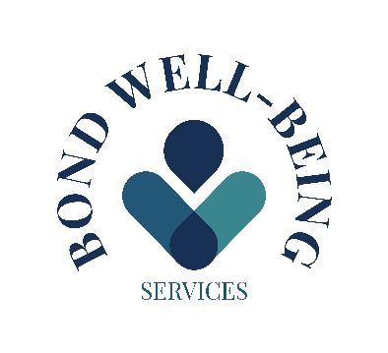
BLOOD TEST CONSENT FORM
I hereby consent for myself, or the person I am legally responsible for, to the drawing of a blood sample by Gaynor Bond at Bond Well-Being Services for the purpose of: _____________________________________________________________________
I understand and accept that:
a) The risks involved with blood draws include, but are not limited to, discomfort at the site of the blood draw, possible bruising, redness and swelling around the site, bleeding at the sight, feeling light-headedness when blood is being drawn, and rarely, an infection at the site of the blood draw.
b) Data derived from this blood draw is considered preliminary only and does not constitute any kind of diagnosis. It is my responsibility to initiate a follow-up examination to confirm results and obtain professional advice and medical treatment.
c) Bond Well-Being Services will keep my results confidential and may only release information to other organisations with my consent.
d) This consent is valid for [3] months, and I have the right to withdraw my consent at any time.
e) I am responsible for any cost not covered by my insurance for this blood draw, and I will receive a bill from the Bond Well-Being Services for any non-covered cost.
I have read (or someone has read to me) the information provided above and understand it. I have been given an opportunity to ask questions, and all of my questions have been answered to my satisfaction.
Patient Signature: ____________________________ Date: [DATE]
Print Name: ________________________________________________
Parent/Guardian Signature: ____________________________ Date: [DATE]
Print Name: ________________________________________________

