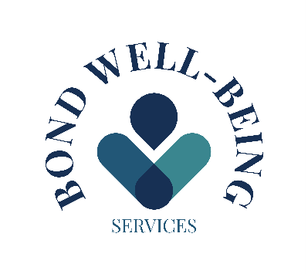

Before any Private Prescription is issued a full history is taken of current medication, drug allergies and current over the counter medications being taken.
You will also be asked if you have any questions regarding the medication.
You will be told how to take the medication, how often and for how long

When you take your private prescription to the pharmacy, the pharmacist will inform you of the cost of the medication.
They will also review any allergies you’ve disclosed and provide guidance on how to take the medication, including possible side effects to be aware of.
It’s important to complete the full course of medication as directed.
If you have any concerns or experience unexpected symptoms, please contact Bond Well-Being Services for advice. In the event of a serious or life-threatening reaction, call 999 immediately.

